5th-6th Grade Rec Basketball Rules

Updated 11/5/2023

Contents
General Rules 2
Playing Time 3
Time Clock 3
Defense 4
Free Throws 5
Technical fouls 5

Note: Age-division specific rules are highlighted in yellow.

General Rules
- All IHSA rules will be followed unless otherwise stated.
- A ball from the home team’s ball bag shall be used. Girls will use a 28.5” (size 6) basketball and boys will use a 29.5” (size 7) basketball.
- Five rostered players are necessary to start a game.
- If a team is unable to put 5 rostered players on the court at the game start, they may borrow a player from the other team in order to play the game.
- A jump-ball will start the game and each overtime period. The possession arrow will change at each jump-ball, start of a quarter or other alternating-possession calls.
- Each team will have two (2) full timeouts per half and one (1) in each overtime period.
- Three (3)-second lane violations on the offense with be called without warning.
- Following a throw-in from out of bounds to the offense’s backcourt, the offensive team has 10 seconds to advance the ball across the half court line.
- Three-point shots are allowed in gyms where there is a 3‐point line.
- The home team shall keep the official scorebook. The scorebook is the official record of the game, playing time, score and fouls.
- The visiting team is responsible for providing a person to run the game clock and scoreboard.
- If a team is not ready to take the court when called by the referees, a 15-second warning will be given. If that team doesn’t take the court in 15 seconds, then a full timeout will be charged. If a timeout is not available a technical foul will be charged to the head coach.
- If a player receives five (5) personal fouls, two (2) technical fouls or a flagrant foul that player is disqualified for the rest of the game. Any player is eligible to replace a disqualified player. This time will not count toward the substitutes overall time played.
- Head Coaches are responsible for the actions of fans, players and assistant coaches. Improper behavior by a spectator will result in a technical foul being charged to the head coach of the associated team. The spectator will also be asked to leave. If this is the second technical on the head coach, he/she will also have to leave the game. There is zero tolerance for any form of physical or verbal abuse.
- HAC disapproves of any form of taunting which is intended to embarrass, ridicule or demean others under any circumstances, including race, religion, gender or national origin.
- Protests are not allowed. All decisions by the referees are final.

Playing Time
- All players must play a minimum of two (2) quarters or 16 minutes, with playing time being distributed as equally as possible.
- If a player arrives late, he or she must only play half of the time that they are there.
- Substitutions are allowed only at sub breaks (4-minute mark of each quarter) or at the start of a quarter. The only other substitutions that will be allowed are if a player gets hurt, or fouls out.
- It is the responsibility of the head coach to ensure playing time is distributed equally. The head coach shall follow the table below to plan playing time.
Number of Players | Maximum Minutes | Minimum Minutes
5 | 5 players – 32 minutes | 5 players – 32 minutes
6 | 4 players – 28 minutes | 2 players – 24 minutes
7 | 5 players – 24 minutes | 2 players – 20 minutes
8 | 8 players – 20 minutes | 8 players – 20 minutes
9 | 4 players – 20 minutes | 5 players – 16 minutes
10 | 10 players – 16 minutes | 10 players – 16 minutes

- Gross violations of playing time will result in forfeiture of the game.

Time Clock
- The game will consist of four (4), 8-minute quarters with a continuous running clock. The clock will stop for the following exceptions:
  - Shooting fouls
  - Timeouts (can be called by a player or head coach)
  - Sub breaks (4-minute mark of each quarter)
  - In the last 2 minutes of the fourth quarter, the clock will stop for all whistles.
- Halftime will be 4 minutes in length.
- Overtime periods will be 3 minutes in length, following a 2-minute break.
  - A jump ball will start each overtime period.
  - A maximum of one (1) overtime will be allowed in a non-playoff game. If the score is still tied after the overtime is complete, a tie will be recorded.
  - For playoff games, additional overtime periods will be added until a team wins.
  - Each team will be allowed one (1) full timeout per overtime period.
  - Overtime will be played the same as the last 2 minutes of each half.
  - Playing time is at the discretion of the coach. Substitutions will only be made at timeouts.

Defense
- Teams must play a minimum of two (2) quarters or 16 minutes of man-to-man defense.
- Team fouls will be counted. If a team incurs 7 team fouls in a half, the opposing team is in the “bonus” and will be awarded a “one-and-one” on the 7th non-shooting foul. If a team incurs 10 team fouls in a half, the opposing team is in the “super-bonus” and will be awarded two free throws on the 10th non-shooting foul.
- Once a team gets control of the ball and possession changes, the other team must immediately fall back on defense. If in the judgment of the referees, a defense player is actively defending in the backcourt, play will be stopped or paused to allow the offensive player relief from the defense.
The referees reserve the right to warn the defense and to charge a player with a technical foul if they believe the backcourt defense is purposeful or intended to interrupt the flow of the game.
- Once the ball enters the offensive front court the entire half court is live. Defenses may half court press unless they are leading by 10 points or more.
- Passes from the backcourt to the frontcourt can be intercepted or stolen as long as the defender is in the offense’s frontcourt.
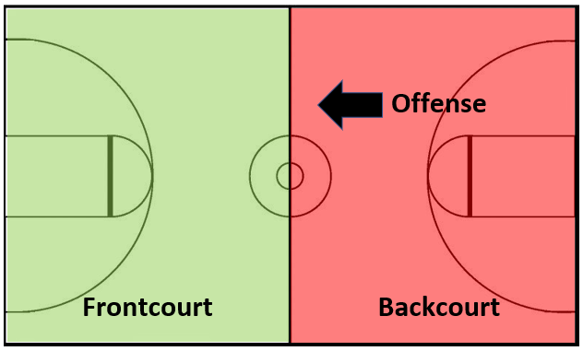
- The last two (2) minutes of the half and the game, either team may full court press if the point span is 5 or less.
- A team trailing by 10 or more points will be allowed to full court press at any time.
- A team winning by 15 points must fall back inside the top of the key extended on defense. This is where you can pick up a player. The ball can only be stolen inside the top of the key extended.

Free Throws
- Foul shots will be allowed if a player is fouled in the act of shooting
- Per IHSA rules (NFHS Rule 9-1-4), after the shooter has received the ball from the referee, he or she has 10 seconds to shoot the ball. Players can move as follows:
  - Players occupying marked lane spaces may leave the lane spaces when the ball is released.
  - The shooter cannot have either foot beyond the vertical plane of the edge of the free-throw line or leave the semi-circle until the ball touches the rim or backboard or until the free throw ends.
  - A player, other than the shooter, who does not occupy a marked lane space, may not have either foot beyond the vertical plane of the free-throw line extended and the three-point line until the ball touches the rim or backboard or until the free throw ends.
- The shooter may cross the free throw line on the release of the ball, however if the line is crossed, he or she may not go after the rebound.

Technical fouls
- If a player receives a technical foul, it also counts as a personal foul.
- Technical fouls do not count as team fouls.
- Any swearing by players or coaches will result in a technical foul.
- Two (2) free throws will be awarded to the opposing team. The opposing team will also get the ball out of bounds after the free throws.
- The player shooting the free throws that were awarded because of the technical foul must have been on the court when the technical foul occurred.
- If a player or a coach receives two (2) technical fouls they are disqualified for the rest of that game.
- Flagrant fouls will result in an immediate ejection. Two (2) shots will be awarded to the opposing team. The opposing team will also get the ball out of bounds after the free throws.
- If a player or coach is disqualified a report must be filed “immediately” with the VP of Basketball.

